TUGAS PRAKTIKUM 1

PEMROGRAMAN 4

Nama : Nadya Hadiyanti

NPM : 4513210027

Langkah – langkah java web dengan maven pada netbeans

1. Membuat project baru, File 🡪 New Project 🡪 Maven 🡪 Web Application

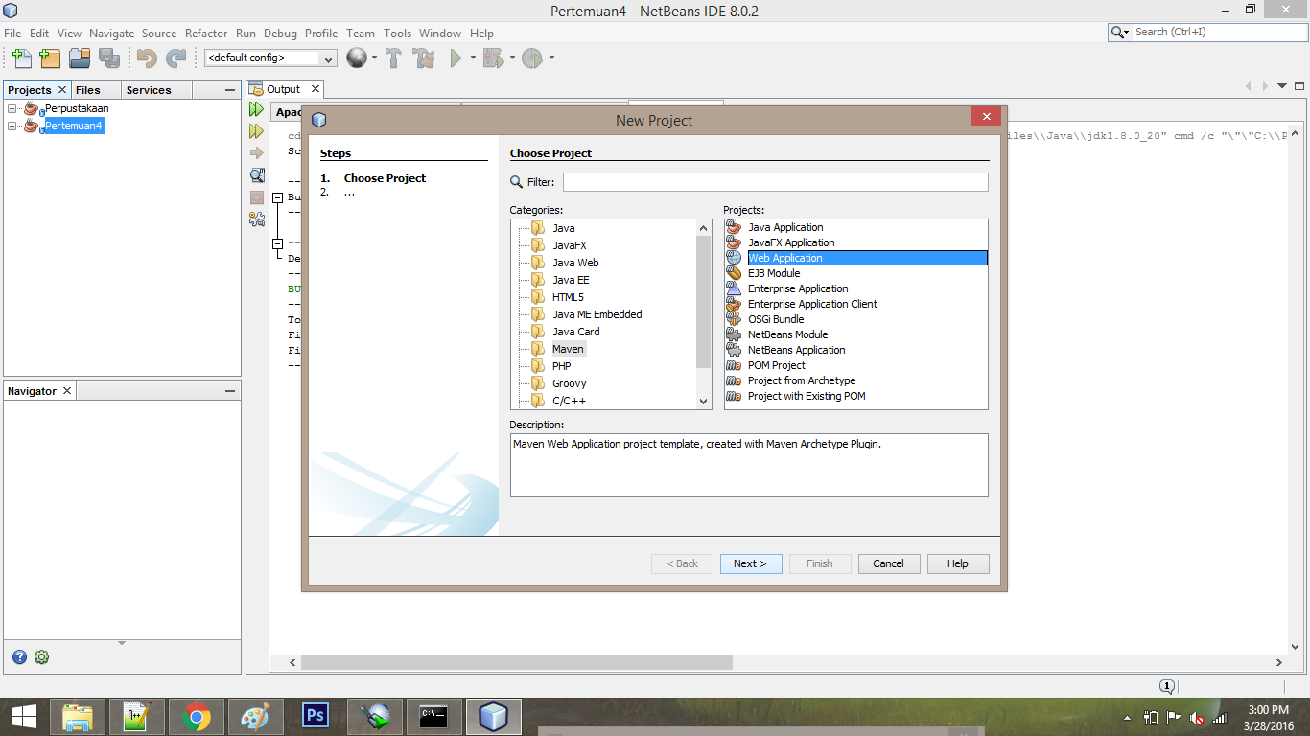

1. Setelah proses pembuatan project selesai, lalu membuat file html dengan klik kanan Web Page 🡪 New 🡪 HTML

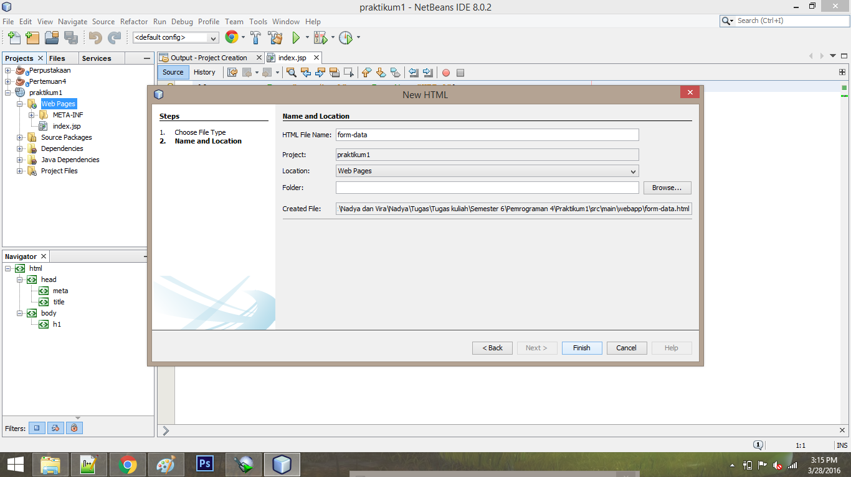

1. Setelah selesai kemudian membuat servlet dengan klik kanan pada Package 🡪 New 🡪 Servlet

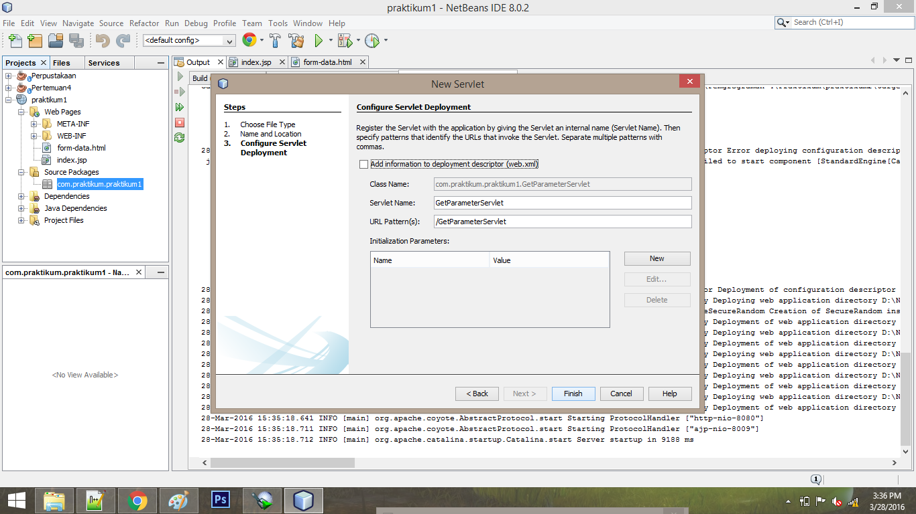

**Print screen**

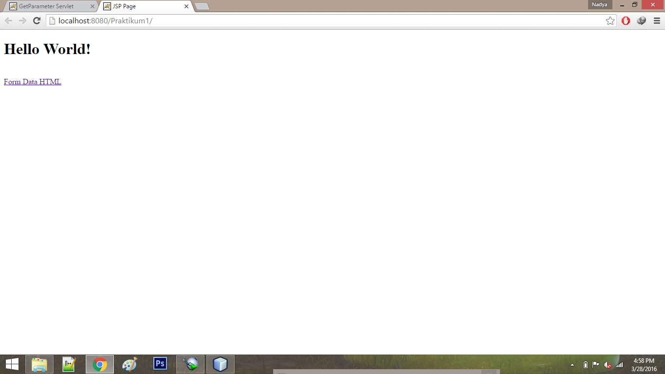

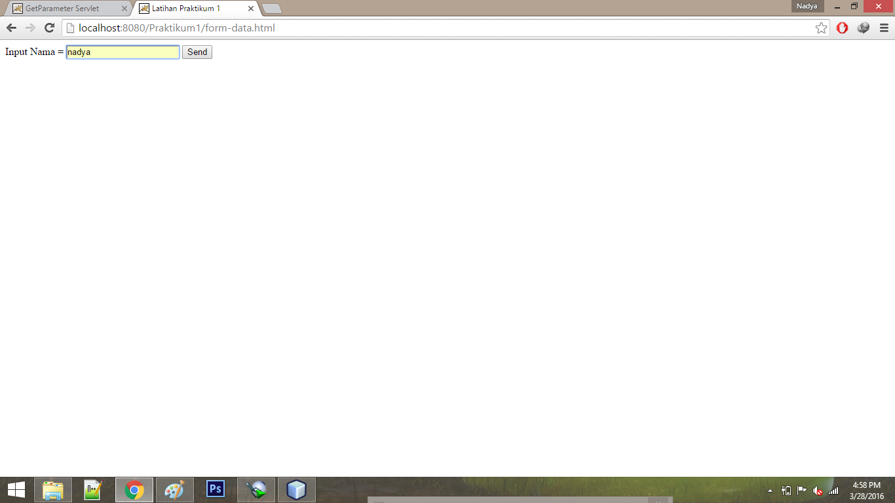

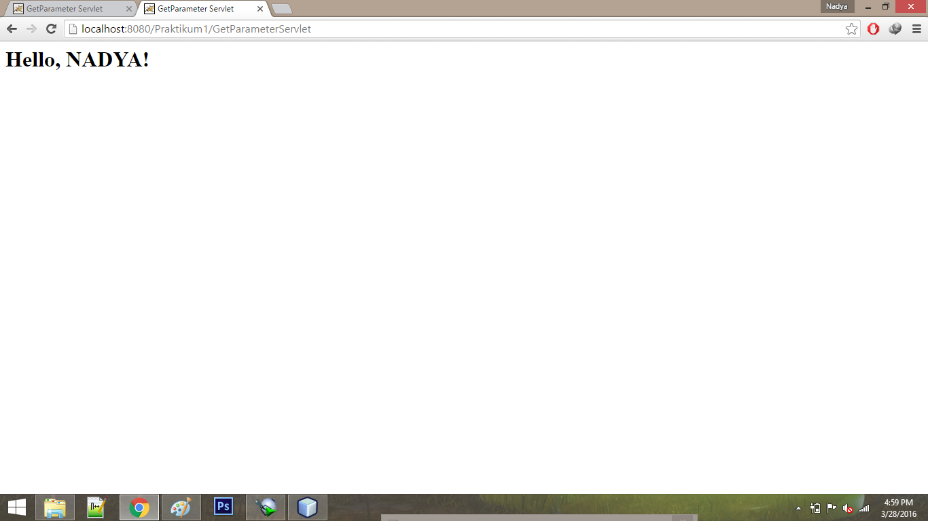

**Deploy dan Undeploy**

|  |
| --- |
| NetBeans: Deploying on Apache Tomcat or TomEE  profile mode: false  debug mode: false  force redeploy: true  Undeploying ...  undeploy?path=/Praktikum1  OK - Undeployed application at context path /Praktikum1  In-place deployment at D:\Nadya dan Vira\Nadya\Tugas\Tugas kuliah\Semester 6\Pemrograman 4\praktikum1\target\praktikum1-1.0-SNAPSHOT  deploy?config=file%3A%2FC%3A%2FUsers%2FNADIAR%7E1%2FAppData%2FLocal%2FTemp%2Fcontext529949144628771262.xml&path=/Praktikum1  OK - Deployed application at context path /Praktikum1  Start is in progress...  start?path=/Praktikum1  OK - Started application at context path /Praktikum1 |